

New Parent Report for Mathematics and Reading Virginia Winter Growth Assessments
The Virginia Department of Education (VDOE) has created a new parent report for the 2023-2024 Winter Virginia Growth Assessment. This report, combined with teacher input, classroom work, report cards, and the Student Detail by Question reports, gives families and teachers a more complete picture of student progress. You can use these results to help identify where your child is doing well and where additional support may be needed. Separate reports for mathematics results and reading results will be available to parents in ParentVue.
Below you will find an example of the chart that will be included in the report. The chart will show your child’s score on the growth assessments they have taken over the course of this school year.
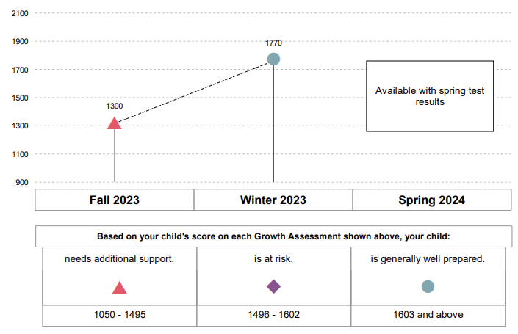
Mathematics 6 Example

Under the chart, the report will list three categories describing your child’s preparedness for the Spring SOL Test in that content area based on their vertical scaled score. The ranges for each category vary by grade level and content area. A similar chart that includes spring SOL results will be provided to parents when spring test results are available.
The report will also include guidance for parents and caregivers, including important questions for classroom teachers and other resources for supporting your child’s reading and mathematics development. More information on this new report can be found at:
https://www.doe.virginia.gov/teaching-learning-assessment/student-assessment
Instructions for Accessing Test Information in ParentVUE
- Open the Roanoke City Public Schools webpage. https://www.rcps.info
- Select Students and Families > ParentVUE/StudentVUE
- Under ParentVUE/StudentVUE, select “ParentVue/StudentVue Login.”
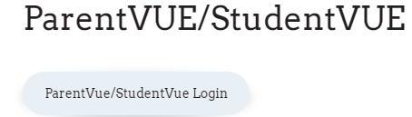

- Select “I am a Parent”
- Login with User Name and Password or select More Options to create a new account.

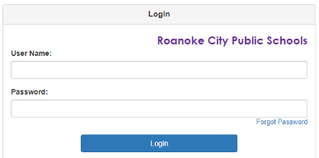
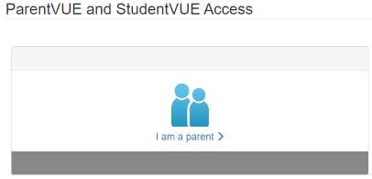

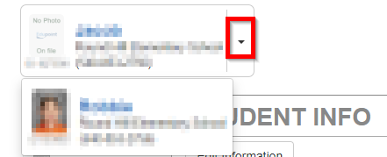
- After logging on the web portal or activating an account, parents will see all their children enrolled in Roanoke City Public Schools in the upper left-hand corner. If there is more than one child, select the dropdown button to select a student.

- On the menu, select Documents. The Virginia Growth Assessment Parent Report will display by test administration.
